Qidigo - KDSR 2027 Musher Registration Steps
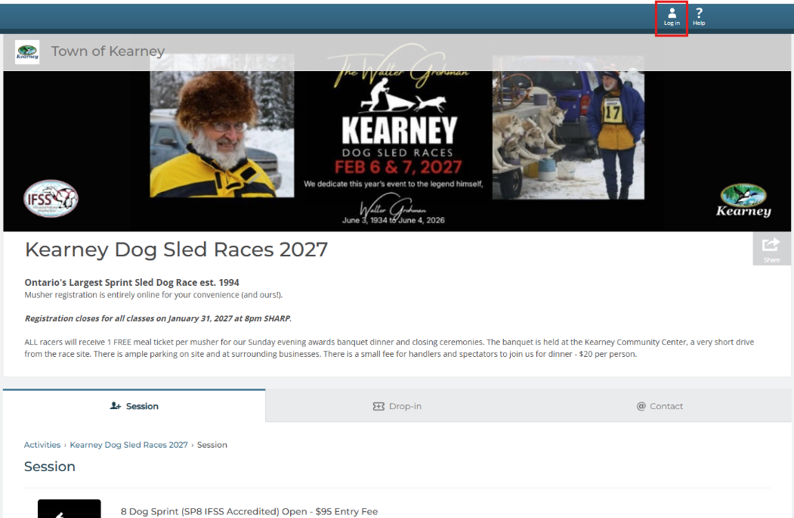
- Visit www.townofkearney.ca/KDSR-musher-registration and click on Login to create your account

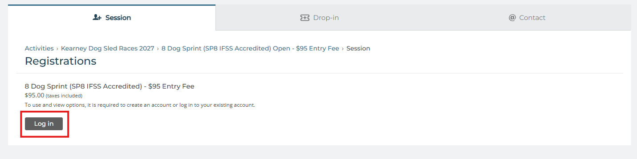
If you click on any of the race classes, it will lead you to the Login/Create an Account page as well

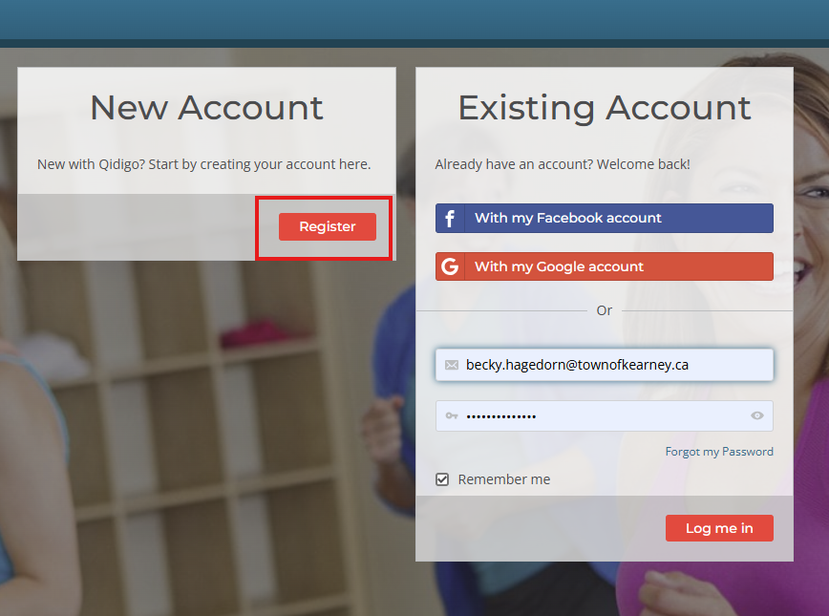
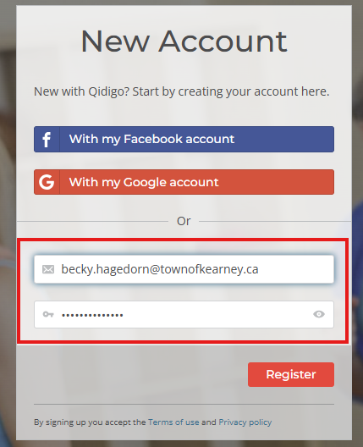
- Click on Register to create your account.
- Fill in the registration details. It will also give you the option add “family members”. For teams with with multiple mushers participating in different race classes, this feature is ideal.
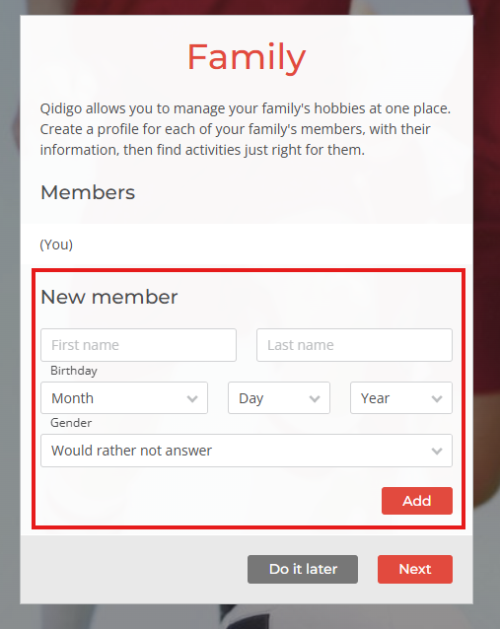
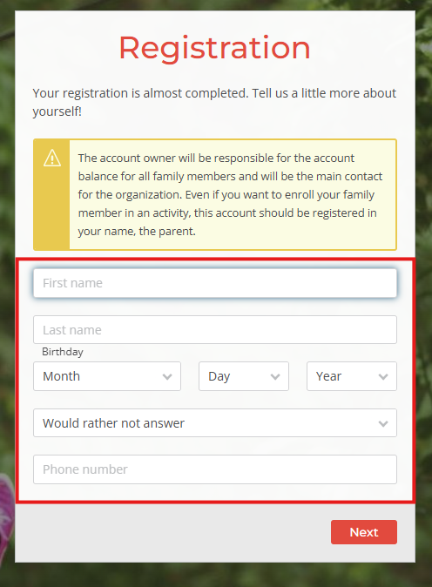

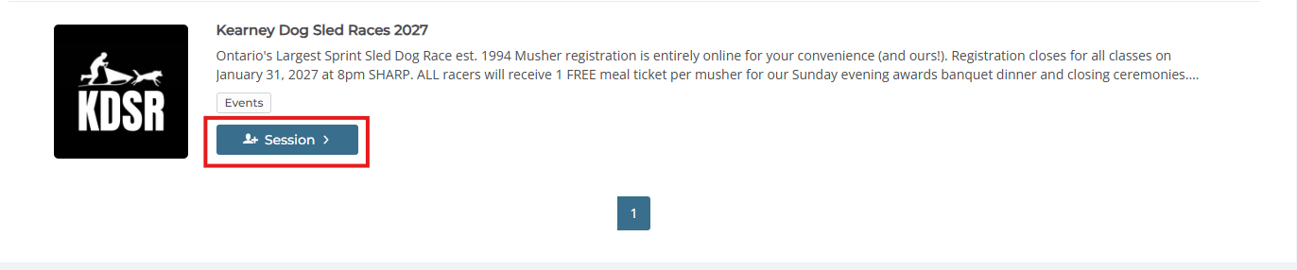
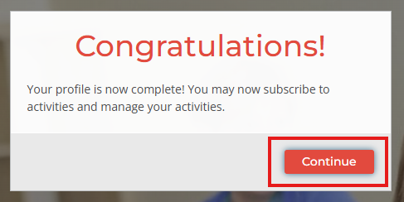
- Once registration is complete, click Continue. Then scroll all the way down to return to the KDSR race registration page and click on Session.

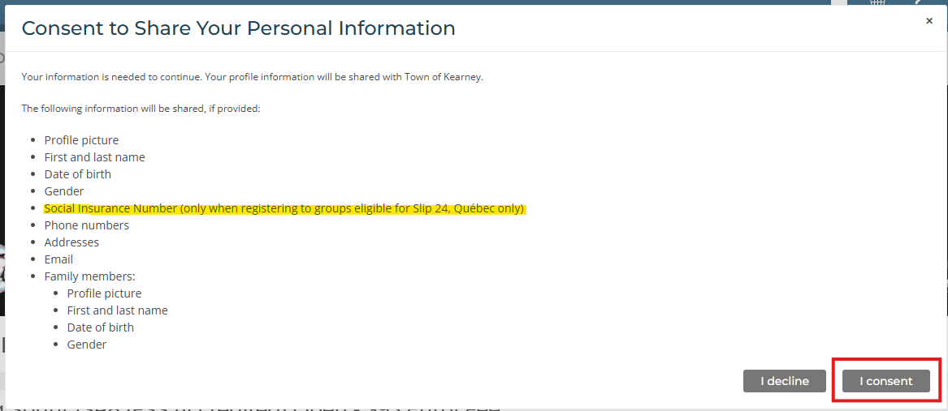
- A pop-up will ask for your consent to share your personal information as you’ve entered it with the Town of Kearney. Please take note that the request for your Social Insurance Number is only applicable to the Province of Quebec. The Town of Kearney will NEVER ask you for your SIN. Click on “I consent”.

- Click on the race class you intend to register for. It will prompt you to select a participant, which will either include yourself or a team member if you’ve entered any. Once your participant is selected, Click “Add to Cart”.
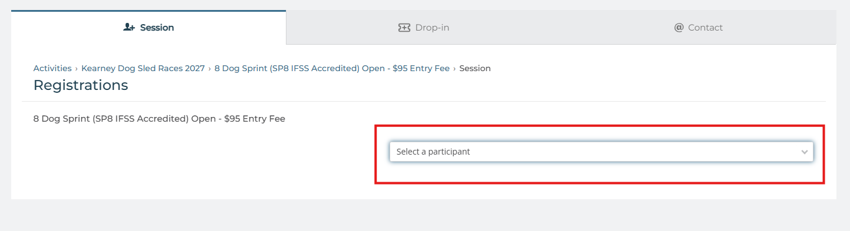

Please note that each participant may register only once per race class. Participants can register for multiple race classes but cannot register for the same class more than once.
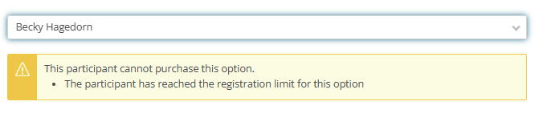
If you attempt to register a participant for a race class they are already registered in, the following error message will appear:

- Once you add the race class to your cart, it will pop-up on the side. Registrants will have 30 minutes to complete their registration from this point. If registering for multiple race classes, participants can click “Continue shopping” and backspace once to return to all race classes. Once all intended race classes have been added to the cart, click “Next Step”.
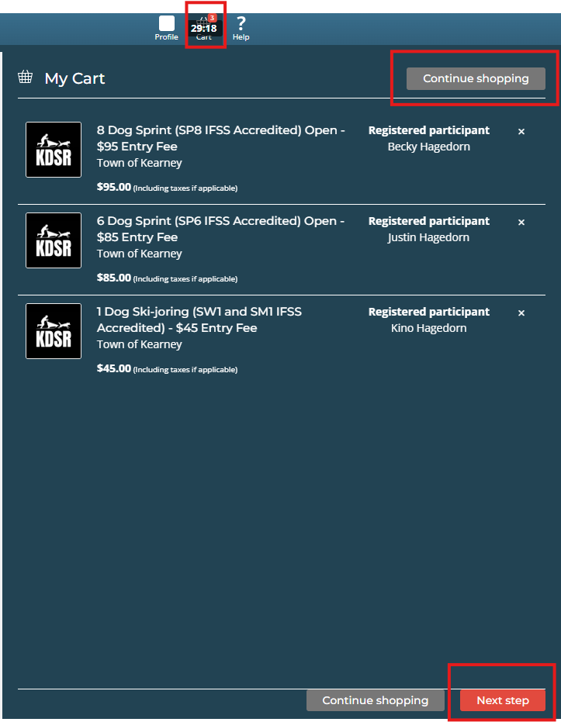

- On the next page, each participant must complete a Musher Registration Form before proceeding. Only one form is required per participant for the entire 2027 race season. Once completed, the form will automatically carry over to any subsequent race registrations, even if a participant cancels one race registration and enters another. Participants can review and update their form at any time by navigating to “Forms” under their profile.
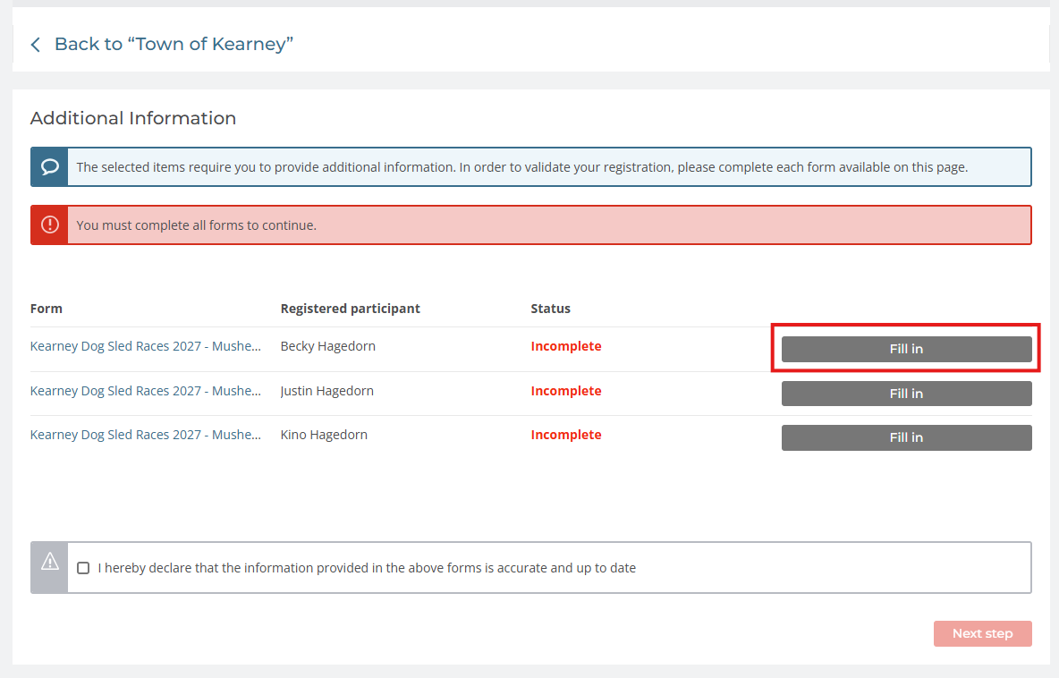

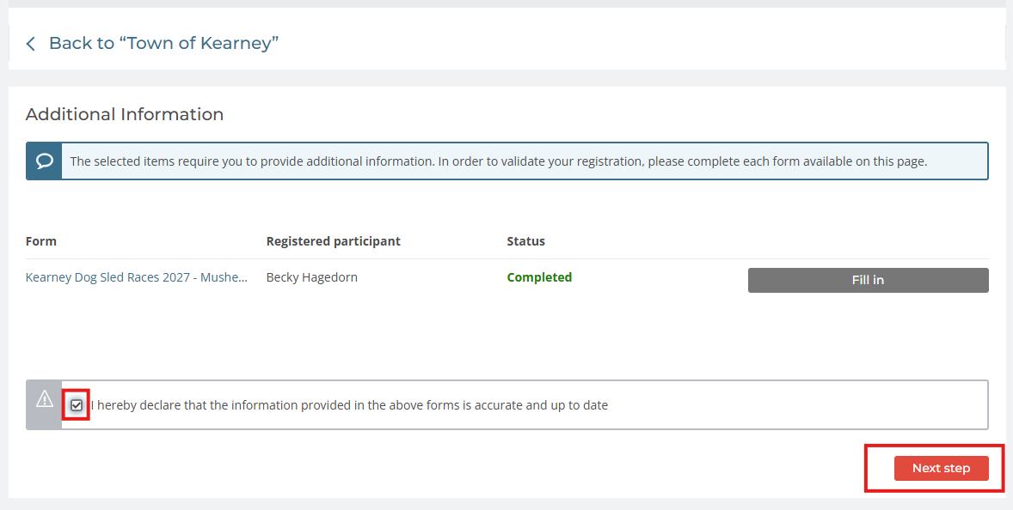
- Once the form is completed, click the checkbox next to “I hereby declare that the information provided in the above forms is accurate and up to date.” Then click “Next Step”.

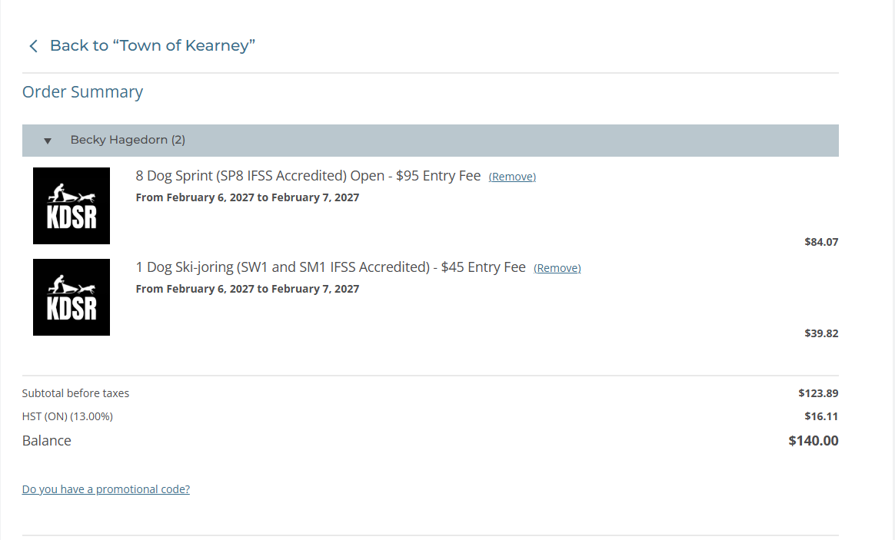
- An Order Summary will show the race classes the participant is registering for, a balance owing and the accepted payment options for completing registration. Upon selection of the payment method, it will detail instructions on how and where to submit payment via that method. E-transfer will most likely be the most popular option, but the Town of Kearney also accepts credit card transactions over the phone, or in-person payment with cash, card or cheque. Credit cards are subject to a 2% transaction fee.

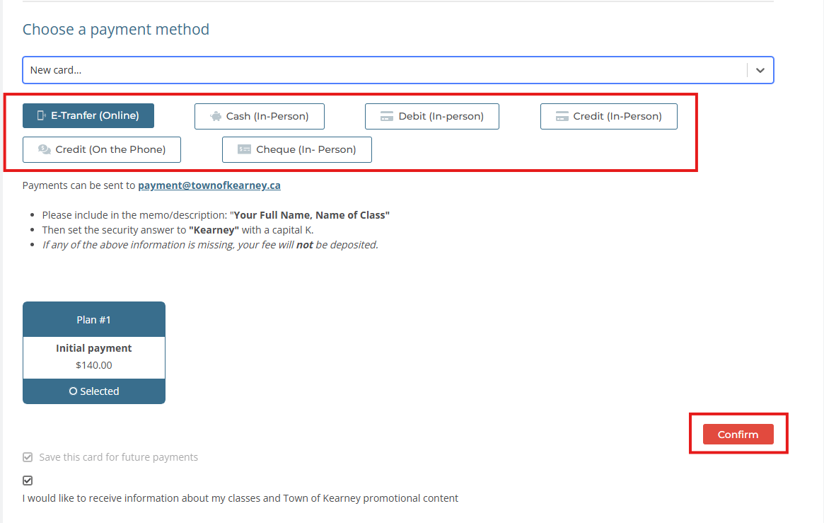
Once the preferred payment method is selected, click “Confirm”. This will generate an invoice to your email address.

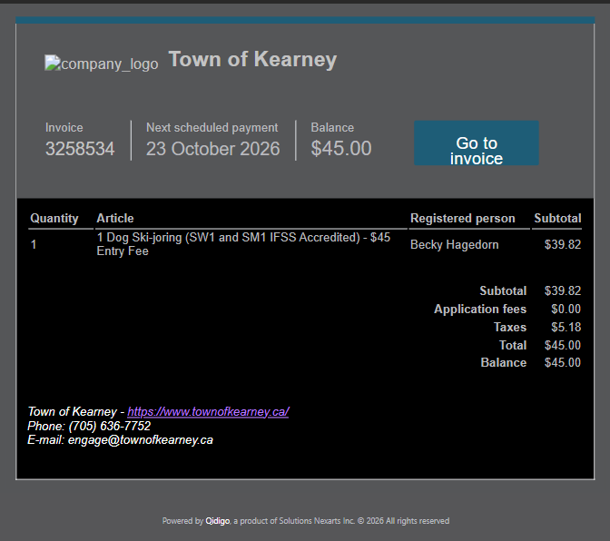

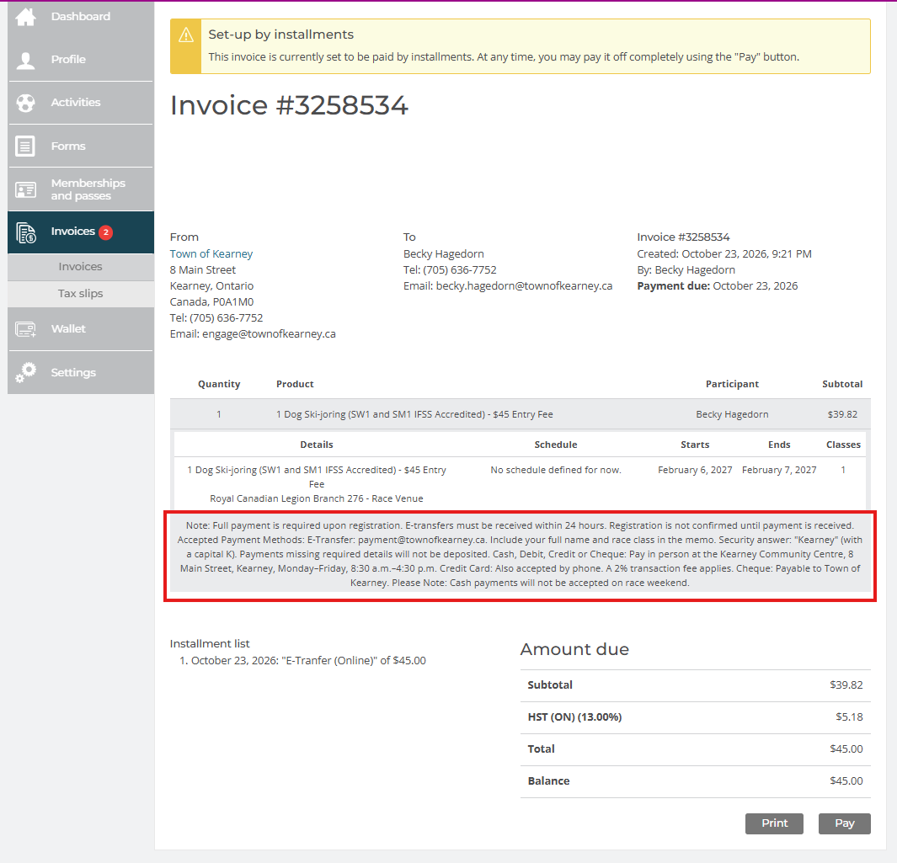
- The next page will show your invoice and its generated invoice number. The invoice further details acceptable payment methods and deadline to pay. Please note that clicking “Pay” at the bottom doesn’t necessarily do anything, since Qidigo is not linked to a third-party payment platform at this time. The only payment options are e-transfer, payment in person or payment over the phone.

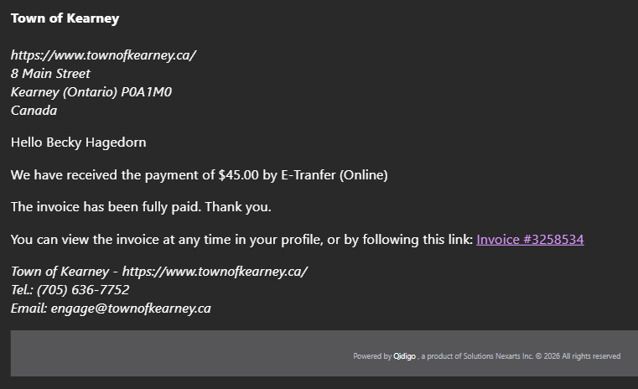
- Once the Town of Kearney receives payment, I will update Qidigo on the backend to mark the registration as paid in full, which will then notify the musher by email that their invoice has been fully paid. Musher registration is complete. For alterations or cancellations, they will need to email me at engage@townofkearney.ca

